April 25 – Bug Docu/Not working functionalities

Faculty Can get and assign subject but Can’t add question
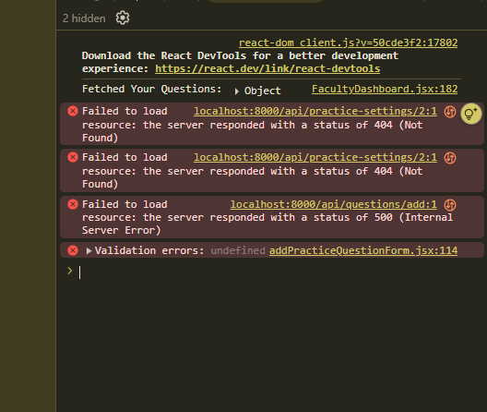

ERROR TEXT:
react-dom_client.js?v=50cde3f2:17802
Download the React DevTools for a better development experience: https://react.dev/link/react-devtools

Fetched Your Questions: ▶ Object FacultyDashboard.jsx:182

❌ Failed to load resource localhost:8000/api/practice-settings/2:1
resource: the server responded with a status of 404 (Not Found)
❌ Failed to load resource localhost:8000/api/practice-settings/2:1
resource: the server responded with a status of 404 (Not Found)
❌ Failed to load resource localhost:8000/api/questions/add:1
resource: the server responded with a status of 500 (Internal Server Error)
❌ Validation errors: undefined addPracticeQuestionForm.jsx:114
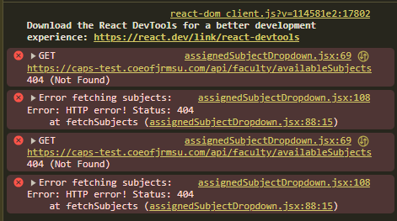
Can’t View and Assign Available Subjects

ERROR TEXT:
assignedSubjectDropdown.jsx:69 GET https://caps-test.coeofjrmsu.com/api/faculty/availableSubjects 404 (Not Found)
assignedSubjectDropdown.jsx:108 Error fetching subjects: Error: HTTP error! Status: 404 at fetchSubjects (assignedSubjectDropdown.jsx:88:15)
assignedSubjectDropdown.jsx:69 GET https://caps-test.coeofjrmsu.com/api/faculty/availableSubjects 404 (Not Found)
assignedSubjectDropdown.jsx:108 Error fetching subjects: Error: HTTP error! Status: 404 at fetchSubjects (assignedSubjectDropdown.jsx:88:15)
﻿

